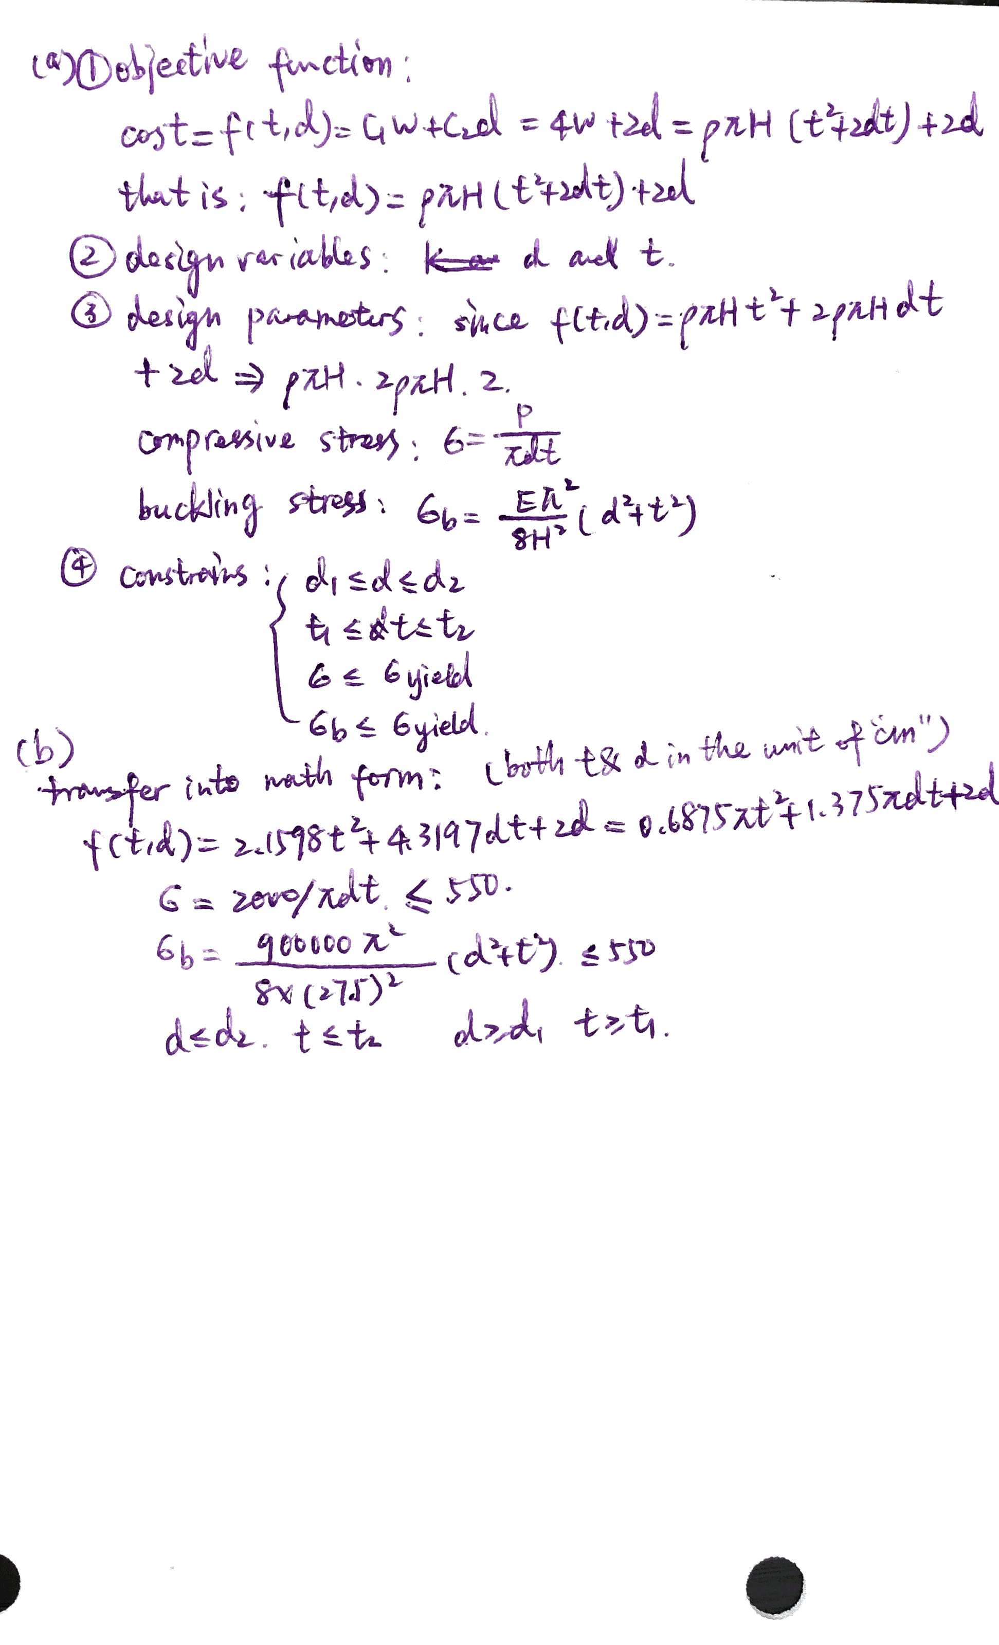

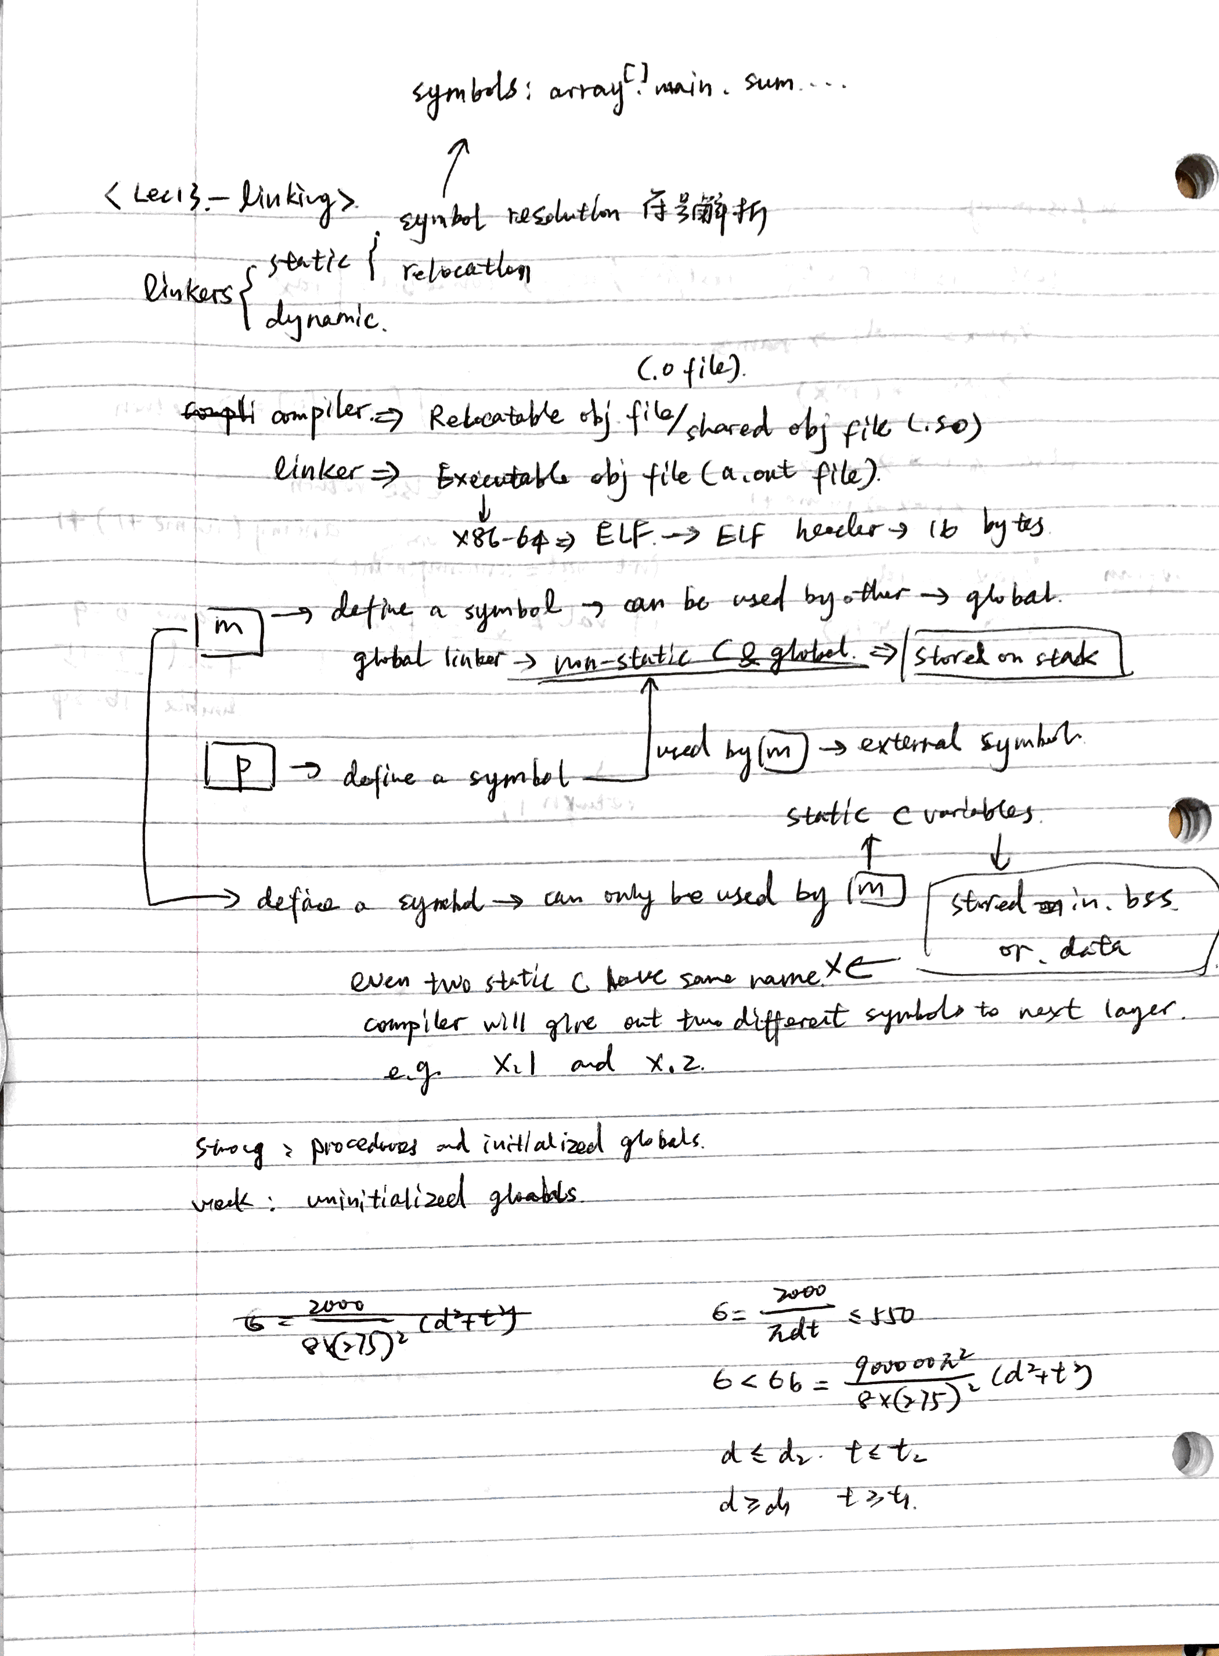

\*Here I choose to compute the mass with real diameter instead of average one since it’s more accurate.

1. The outcome is: d=5.8143cm, t=0.2203cm

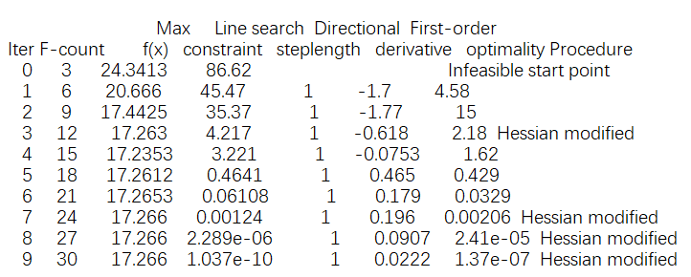

1. The outcome is: d=5.8143cm, t=0.2203cm

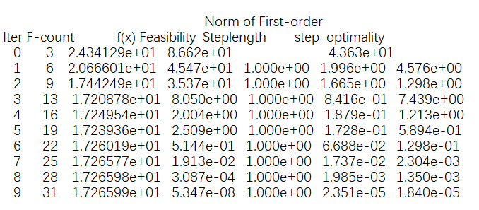

1. The outcome provided in question (b) and (c) agree with each other.

Now choose different sets of initial values:

1. Initial value [1,1]

Active set: 5.814258521825271 0.220286189536100

SQP : 5.814258875069966 0.220286149560716

1. Initial value [10,0.1]

Active set: 5.814258853376688 0.220286152016966

SQP : 5.814258850127767 0.220286152361251

1. Initial value [1000,1000]

Active set: 5.814258870893127 0.220286150033593

SQP : 5.814258606792436 0.220286179895046

From the data above, although there exists small difference in the result, the final solution is generally consistent between the two algorithms.